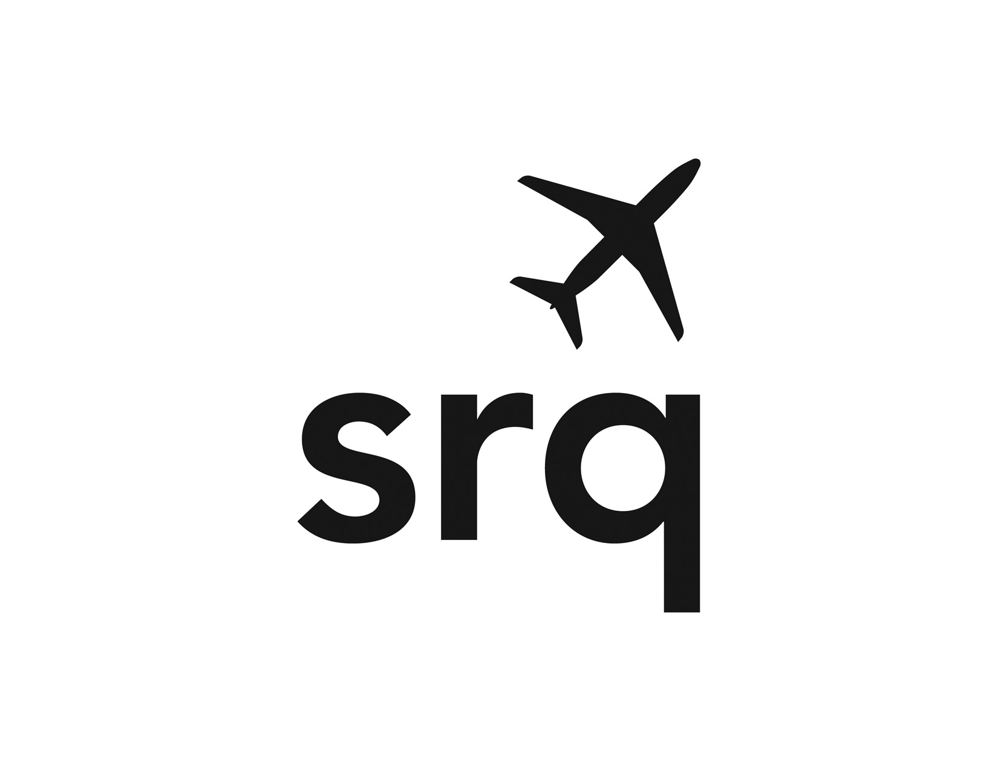
SARASOTA MANATEE AIRPORT AUTHORITY

Pursuant to Section 189.417 FL Statutes, the SMAA hereby gives notice of its schedule of meetings for 2026. REGULAR MEETINGS OF THE SARASOTA MANATEE AIRPORT AUTHORITY shall be held at the Sarasota Bradenton International Airport, Dan P. McClure Auditorium, 6000 Airport Circle, Sarasota. The auditorium is located on the first floor of the terminal.
Regular meetings:
Monday, FEBRUARY 9
Monday, MARCH 23
Monday, MAY 11
Monday, AUGUST 24
Monday, SEPTEMBER 28
Tuesday, NOVEMBER 17
Regular meetings begin at 1:00 p.m. Additionally, the Board will hold a workshop meeting on May 11 at 11:00 a.m. to assess the performance of the President, CEO, and a budget workshop on August 24 at 11:00 a.m. If necessary, the Board shall schedule a second budget workshop for the first Wednesday after Labor Day, Wednesday, September 9.

Any regular or workshop meeting of the board may be recessed to be later reconvened on a date certain. There may be other workshops and special meetings scheduled throughout the year. Notices of those meetings shall be published at least seven days prior to the meeting occurrence. Notices of any other meetings conducted under the auspices of the Authority, which are required to be noticed under s.286.011, F.S., shall be posted on the first floor of the Airport terminal in the display case near the main elevators, for a minimum of seven days, or, in the case of an emergency, two days, in advance of the meeting.

We invite the public to attend. If a person decides to appeal any decision made by the Airport Authority with respect to any matter considered at these public meetings, they will need a record of the proceedings, and for such purpose, they may need to ensure that a verbatim record of the proceedings is made, which record includes the testimony and evidence upon which the appeal is to be based. Pursuant to the Americans with Disabilities Act, persons needing assistance to participate in any of these meetings should contact Carina Renault, Executive Assistant, at 941-359-2770 ext. 4216 or email at carina.renault@flysrq.com.

You may obtain any formal request for proposal/solicitation by Airport Authority online at www.demandstar.com, www.flysrq.com under Airport Business/Bid Announcements, or by contacting DemandStar by Onvia toll-free at 800-711-1712 and requesting current solicitation.

